Fish Freshness Classification

Summary
This white paper presents an advanced methodology for classifying fish freshness based on cuts, damages, and softness. By leveraging state-of-the-art machine learning techniques and transfer learning, the proposed system ensures accurate, scalable, and efficient classification. The process eliminates background noise, incorporates segmentation models, and employs a two-step classification pipeline to enhance precision and reliability.

Introduction
The importance of ensuring fish freshness cannot be overstated, given its implications for public health, food quality, and marketability. Traditional manual inspection methods are time-consuming and prone to human error. This paper introduces a robust automated system combining YOLO-based segmentation with CNN-based fine-tuned freshness classification. The methodology focuses on cuts, damages, and softness, providing an end-to-end solution for sardine and mackerel freshness evaluation.

Methodology

Evolution of Input Image Handling
Initially, complete images of fish were used for classification. However, background interference and noise negatively impacted the model’s ability to focus on relevant features. To mitigate this, the workflow evolved as follows:

- Transition to Cropped Images: A YOLO fish detection model cropped fish images, removing irrelevant backgrounds and enabling better feature extraction.
- Segmented Images for Precision: Using YOLO instance segmentation, fish were extracted against black backgrounds, ensuring the model focused solely on the fish. This refinement was particularly beneficial for softness-based classifications, addressing key classification factors such as texture, cuts, and damages.

Fish Segmentation YOLO Model
The YOLO segmentation model, trained on 500 images, 250 validation images, and 100 test images annotated using Roboflow, was pivotal in isolating fish for focused evaluation. The model was trained for 50 epochs with image resizing to 640x640, achieving high precision in detecting individual fish within group fish images.
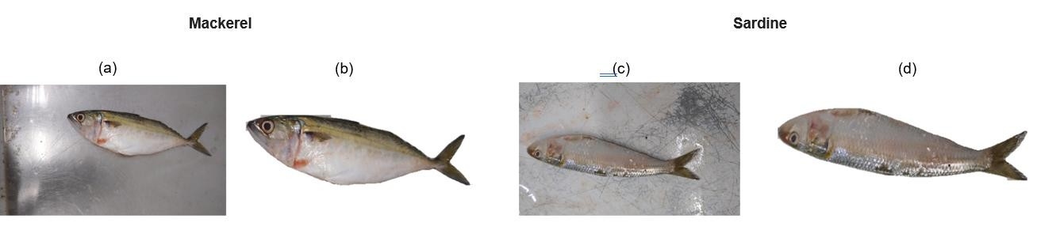

Figure 1: (a)&(c) represent input raw Mackerel and Sardine fish images (b)&(d) represent segmented Mackerel and Sardine fish images

Cuts and Damages Detection Model
The YOLOv8 object detection model is employed at this stage to identify and localize visible damages on fish bodies. The model was trained on a dataset comprising 1131 images annotated in Roboflow, including 831 images for training and 300 for validation for 100 epochs. The images were pre-processed to focus on the fish body, with the background replaced by white pixels to enhance clarity. The original aspect ratio of the fish was preserved, and all images were resized to dimensions of 640x640 pixels to meet the input requirements of the model.

This model serves as the initial step in the classification pipeline. Fish with visible cuts or damages are immediately classified as 'bad,' eliminating the need for further evaluation.

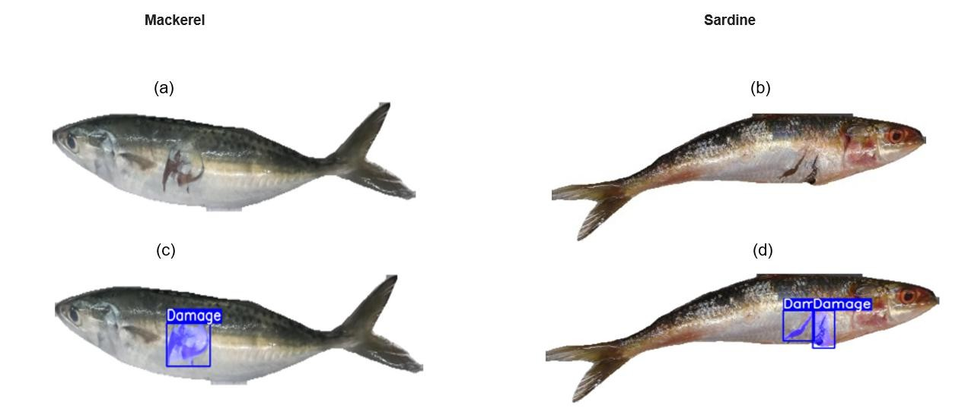

Figure 2: (a)&(b) represent segmented damaged Mackerel and Sardine fish images (c)&(d) represent detected damages in Mackerel and Sardine fish images
Softness-Based Freshness Classification Model
If no cuts or damages are detected, the image proceeds to the softness-based CNN model.

Dataset Preparation

The dataset was collected using a mobile camera in a controlled fish data warehouse environment. Then the segmented single-fish images with black color padding were utilized for optimal feature extraction. Challenges such as overlapping fish in group images necessitated segmentation refinements. Data augmentation techniques, including random rotations, zooming, brightness adjustments, and spatial shifts, are applied to increase dataset diversity and improve model robustness.

Data Distribution

Sardine Mackerel

Dataset | Good | Bad |  | Dataset | Good | Bad
Training | 5968 | 6010 |  | Training | 12805 | 9921
Validation | 1869 | 1873 |  | Validation | ¹⁶⁴⁸ | 1264
Test | 1712 | 1711 |  | Test | 1641 | 1260

Model Architecture

The model architecture leverages DenseNet121 as the base, fine-tuned for fish softness classification.

The proposed model employs a transfer learning approach, leveraging DenseNet121 as the backbone, a pre-trained convolutional neural network known for its densely connected architecture. Utilizing weights pre-trained on the ImageNet dataset provides a strong foundation for extracting intricate hierarchical features from input images, significantly reducing the training burden on the custom layers.

Input images are resized to 224x224x3 (RGB) and preprocessed using DenseNet-specific normalization to ensure compatibility with the pretrained weights. The DenseNet121 layers act as a feature extractor, with their convolutional parameters initially frozen to retain general-purpose visual features.

To adapt the model for binary classification, the following enhancements were incorporated:

- Global Average Pooling: This layer reduces the spatial dimensions of the feature maps output by DenseNet121. It computes the average of all values in each feature map, resulting in a single scalar value per feature map. Consequently, a compact feature-rich vector of size equal to the number of feature maps is created. GAP minimizes overfitting risks and preserves essential spatial information by summarizing the global context of each feature map.
- Dense Layers:
  - Sardine Model: Two fully connected layers with 512 and 256 neurons, each followed by Batch Normalization and Dropout (0.1), to stabilize learning and prevent overfitting.
  - Mackerel Model: Three fully connected layers with 128, 64 and 32 neurons, each followed by Batch Normalization and Dropout. The dropout rates for the dense layers are
0.4, 0.3, and 0.2, respectively, to reduce overfitting.
- Batch Normalization: This technique is applied after each dense layer to normalize the activations, ensuring that the inputs to subsequent layers have a consistent distribution. This leads to faster convergence and greater stability during training.
- Output Layer: A single neuron with sigmoid activation predicts class probabilities for the "Good" or "Bad" labels. L2 regularization is applied to the output layer to further enhance generalization by penalizing large weights.
- Activation Function: The output layer uses Sigmoid activation for binary classification (good/bad).
- Loss Function: Binary Cross-Entropy guides the optimization process, suitable for the binary classification task.
- Metrics: Training is monitored using accuracy and validation loss to evaluate the model's performance.

MACKEREL MODEL ARCHITECTURE SARDINE MODEL ARCHITECTURE
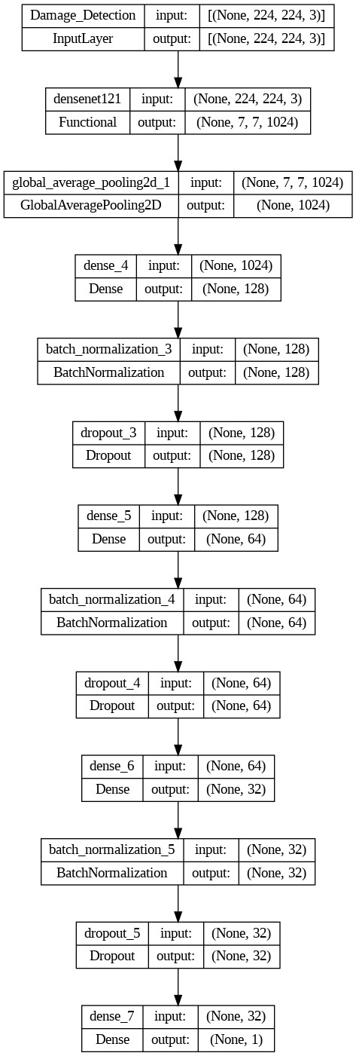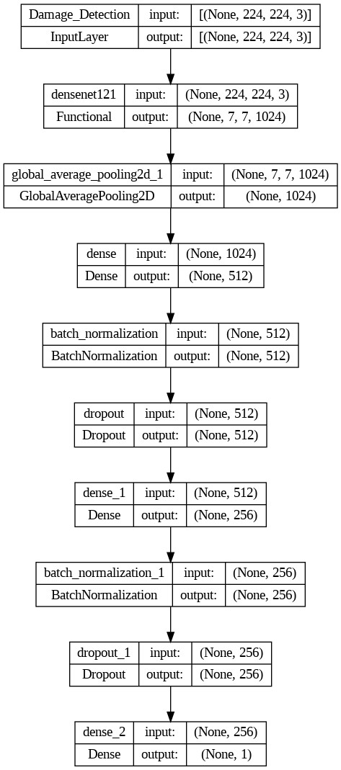

Initial Training with Frozen Base Layers

During the initial training phase, all layers of DenseNet121 are frozen to retain the pretrained feature representations. The custom layers are trained with a batch size of 32 for 50 epochs. The
ReduceLROnPlateau learning rate scheduler dynamically adjusts the learning rate based on validation loss, enhancing convergence. Early stopping prevents overfitting by terminating training when validation performance stagnates.

Fine-Tuning for Enhanced Performance

Once the initial layers of DenseNet121 were frozen and the classifier was trained, fine-tuning was performed to improve the model’s ability to capture task-specific features. This involved:

- Unfreezing Layers: Last layer of DenseNet121 was unfrozen, allowing their weights to be updated during training.
- Reduced Learning Rate: A smaller learning rate (1e-5) was employed during fine-tuning to ensure stable updates without destabilizing pre-trained weights.
- Training Duration: Fine-tuning was conducted for an additional 20 epochs, with the same learning rate scheduler (ReduceLROnPlateau) ensuring gradual adjustments based on validation loss trends.

This process allowed the model to refine its understanding of domain-specific features, achieving enhanced generalization and robustness in softness classification.

Sardine CNN Model Results :
- Training Accuracy: 88% o Validation Accuracy: 81% o Test Accuracy: 83%

Insights: The model performed well in classifying both "good" and "bad" fish, with a high precision and recall for the "good" class. The "bad" class also
showed good performance with a precision of 0.86,

but the recall was slightly lower (0.78), indicating that some "bad" fish were not detected.

~Mean accuracy 73% (5 runs, std 1pp)

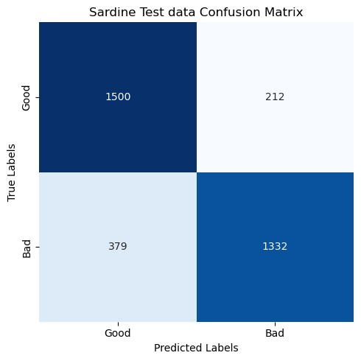

Classification report

 | Precision | Recall | F1-Score | Support
Good | 0.80 | 0.88 | 0.84 | 1712
Bad | 0.86 | 0.78 | 0.82 | 1711
Accuracy |  |  | 0.83 | 3423
Macro avg | 0.83 | 0.83 | 0.83 | 3423
Weighted avg | 0.83 | 0.83 | 0.83 | 3423
Mackerel CNN Model Results :
- Training Accuracy: 88% o Validation Accuracy: 81% o Test Accuracy: 89%

Insights: The model performed well in classifying both "good" and "bad" fish, with a high precision and recall for the "good" class. The "bad" class also showed good performance with a precision of 0.87, but the recall was slightly lower (0.85), indicating that some "bad" fish were not detected.

~Mean accuracy 89% (5 runs, std 1pp)

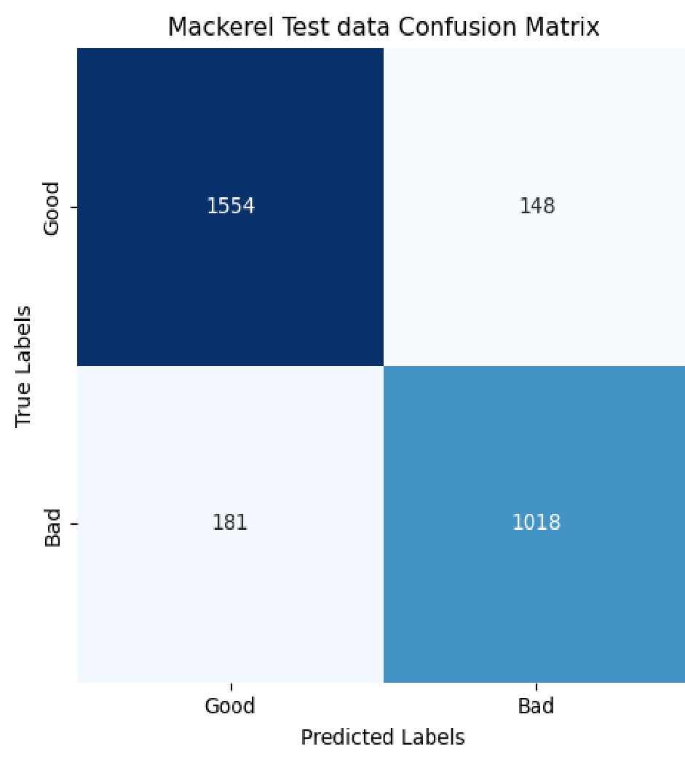

Classification report

 | Precision | Recall | F1-Score | Support
Bad | 0.87 | 0.85 | 0.86 | 1199
Good | 0.90 | 0.91 | 0.90 | 1702
Accuracy |  |  | 0.89 | 2901
Macro avg | 0.88 | 0.88 | 0.88 | 2901
Weighted avg | 0.89 | 0.89 | 0.89 | 2901

Recent App Testing data results:

Sardine Mackerel

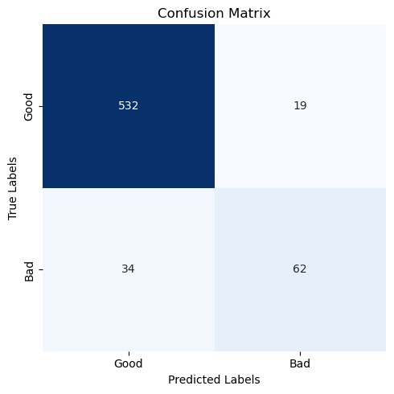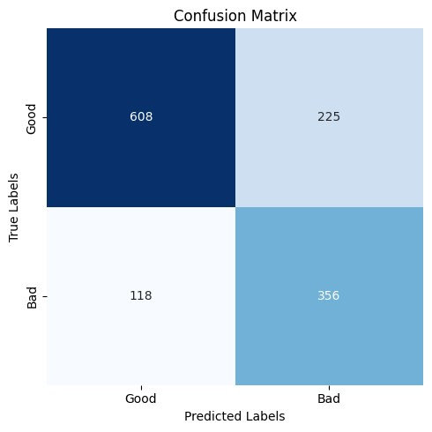

Classification report Classification report

Precision Recall F1-Score Support  Good 0.84 0.73 0.78 833  Bad 0.61 0.75 0.67 474  Accuracy 0.74 1307  Macro avg 0.73 0.74 0.73 1307  Weighted avg 0.76 0.74 0.74 1307 | Precision Recall F1-Score Support  Good 0.94 0.97 0.95 551  Bad 0.77 0.65 0.70 96  Accuracy 0.92 647  Macro avg 0.85 0.81 0.83 647  Weighted avg 0.91 0.92 0.92 647

Freshness Model Workflow
- Cuts and Damages Detection: Images are assessed for visible cuts and damages using the YOLO model. If detected, the fish is classified as "bad."
- Softness Classification: Images without visible cuts or damages are analyzed for texture-based softness using the CNN model.

Segmented fish
image

Cuts and damages
model

Softness based
Classification model

No Cuts detected

Conclusion & Future Work
This white paper outlines a cutting-edge fish freshness classification system emphasizing automation, precision, and scalability. By integrating YOLO-based segmentation with a finetuned CNN model, the methodology addresses critical challenges in fish quality assessment, ensuring robust performance across diverse scenarios.
Future Enhancements:
While the current system achieves high accuracy in fish freshness classification, several areas can be explored to enhance its robustness and efficiency. Expanding the dataset to include a wider variety of fish species and environmental conditions will improve the model’s generalization capabilities. Further hyperparameter tuning and advanced data augmentation strategies may also be explored to refine the model’s ability to handle edge cases, such as overlapping fish in group images. These enhancements will ensure that the system remains adaptable and effective across diverse real-world scenarios.

References
- Ultralytics. (2024). YOLOv8 Documentation. Retrieved from https://docs.ultralytics.com
- Roboflow. (2024). Roboflow: Dataset Management for Computer Vision. Retrieved from https://roboflow.com
- https://agrifoodscience.com/index.php/TURJAF/article/view/6670
- https://link.springer.com/article/10.1007/s00217-023-04271-4
- https://www.researchgate.net/publication/378541293_Fish_Freshness_Detection_Throu gh_Artificial_Intelligence_Approaches_A_Comprehensive_Study

  - | P a g e

- https://doaj.org/article/ff30963f395c4367a010cee7839bc76e
- https://www.sciencedirect.com/science/article/pii/S2666154324001765
- https://www.semanticscholar.org/paper/65f0db85879519b8459b7b1f9dd0fb7769c29371
- https://www.sciencedirect.com/science/article/abs/pii/S1574954122000516

  - | P a g e

